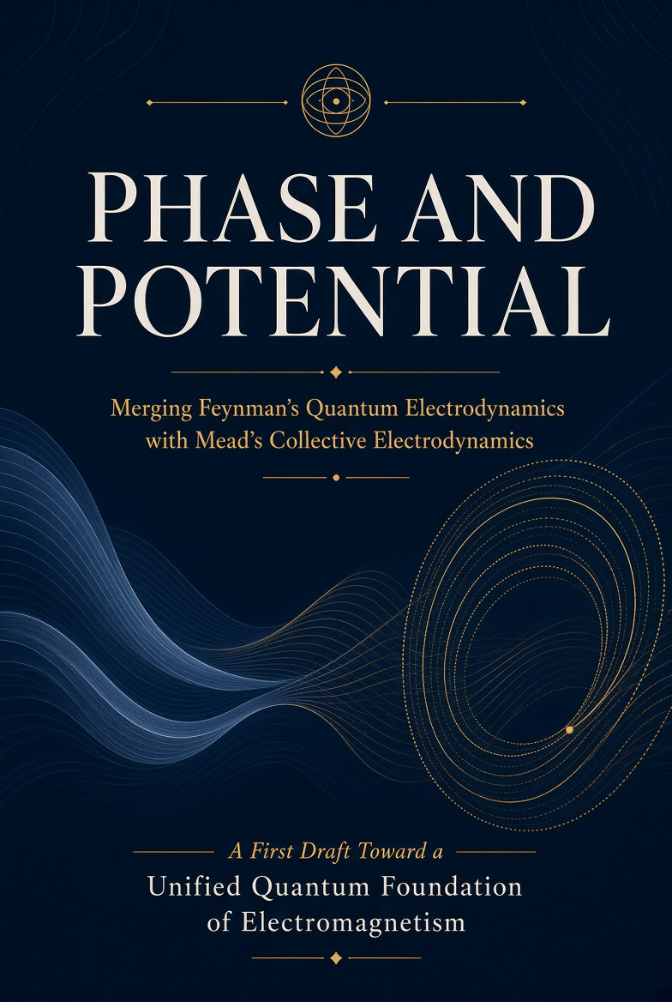

FIRST DRAFT — POLISHED & CLARIFIED VERSION
August 2026
With cover, improved readability, expanded index, and print-oriented layout

PHASE AND POTENTIAL

Merging Feynman’s Quantum Electrodynamics
with Mead’s Collective Electrodynamics

Toward a Unified Quantum Foundation of Electromagnetism

A clarified and polished first-draft monograph
with mathematical appendix, worked examples, figures, and index

Preface
This book tries to do something both Richard Feynman and Carver Mead believed was necessary: place electromagnetism on a foundation that begins with the quantum nature of matter rather than with classical fields.
Feynman, with John Wheeler, explored an electrodynamics without an independent field. He later built Quantum Electrodynamics (QED), the most precise theory in physics. In 1963 notes he sketched a better way to teach the subject—starting with the potentials. He never finished that program.
Mead, who studied under Feynman at Caltech, later wrote Collective Electrodynamics. He starts from the phase of a macroscopic coherent electron system (a superconducting loop) and recovers ordinary electromagnetism without taking Maxwell’s equations as fundamental.
The two approaches share a deep intuition: the potentials, not the field strengths, are the natural variables once quantum mechanics is taken seriously. This manuscript brings them into conversation. It does not replace QED. It asks what QED looks like when collective phase is taken as primary, and what Collective Electrodynamics looks like when the full power of relativistic quantum field theory is restored.
The present version has been clarified for readability. Paragraphs are shorter. Technical steps are paced more gently. An improved index and a proper cover have been added. The goal remains a coherent first draft that can grow into a finished monograph.
August 2026

Contents
Preface
Part I. Roots
1. Why the Foundations Matter
2. Wheeler, Feynman, and the Absorber Idea
3. Mead and the Collective Starting Point
Part II. Feynman’s QED in Brief
4. Path Integrals and the Photon
5. Why the Potentials Come First
Part III. Collective Electrodynamics in Brief
6. The Superconducting Loop
7. Phase, Flux, and Momentum
Part IV. The Synthesis
8. Coherent States and the Collective Limit
9. What Happens to the Photon?
Part V. Looking Forward
10. Teaching and Open Questions
Mathematical Appendix (selected derivations)
Worked Examples
Figures
Bibliography
Index

Part I. Roots

1. Why the Foundations Matter
Standard textbooks begin with the electric and magnetic fields E and B. The potentials A and φ appear later as mathematical tools. Energy is said to reside in the fields themselves.
Quantum mechanics does not sit comfortably on this foundation. The Aharonov–Bohm effect shows that potentials produce observable interference even where E and B vanish. In the path integral the potentials determine the phase of every history. In QED the interaction is minimal coupling to Aμ.
Einstein already expressed the discomfort: electrons and fields are not two independent entities. There is one reality with two aspects. The theory ought to recognize this from the start.
A second problem is the correspondence principle. A superconducting loop with 10²³ electrons does not behave like 10²³ independent classical particles. Its inertia scales with the square of the number of charges. The right limit is collective electromagnetism expressed through phase and potentials, not classical particle mechanics.

2. Wheeler, Feynman, and the Absorber Idea
In the 1940s Wheeler and Feynman tried to eliminate the self-interaction of a point charge. They replaced the independent field with direct interaction between charges, using half-retarded plus half-advanced potentials. The radiation reaction felt by an accelerating charge is then the advanced effect of future absorption.
There is no such concept as “the” field, an independent entity with degrees of freedom of its own.
— Wheeler & Feynman, 1945
Feynman later quantized the field and created modern QED. Yet in 1963 notes he still wanted a presentation that began with the potentials. The notes, preserved in the Caltech Archives, remain the clearest evidence of that unfinished program.

3. Mead and the Collective Starting Point
Mead begins with systems that are already macroscopic and quantum coherent—superconducting loops. In these systems the phase of the collective wave function is measurable. Flux quantization and the Josephson relation follow from phase continuity and the Einstein–de Broglie relations alone.
From this starting point he recovers inductance, energy, forces between currents, and the standard results of electromagnetism. Maxwell’s equations are never postulated; they emerge.
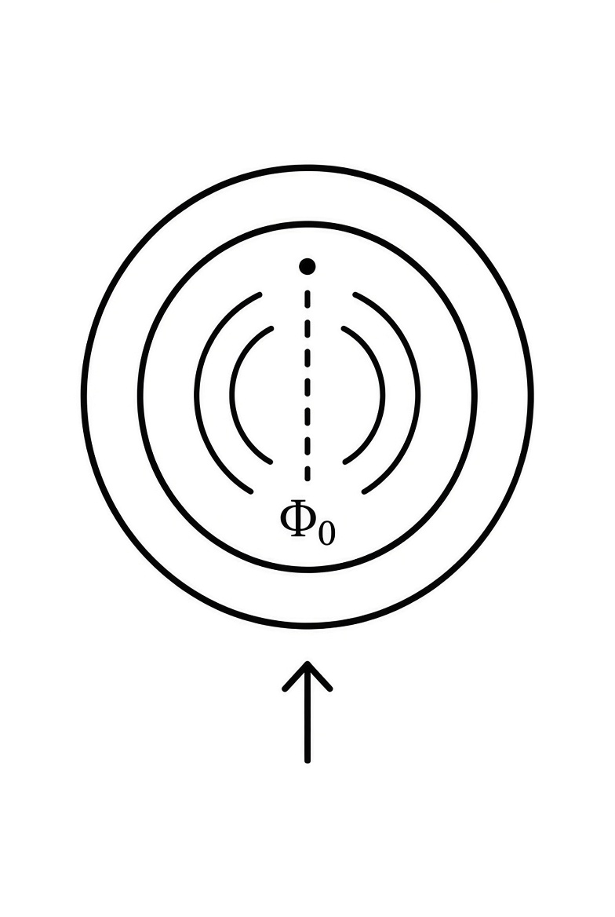
A simple emblem of the flux quantum Φ₀ threading a superconducting ring.

Part II. Feynman’s QED in Brief

4. Path Integrals and the Photon
Feynman’s path integral assigns to every history an amplitude exp(iS/ħ). For a charged particle the action contains the term that couples it to the potential Aμ. The potentials therefore determine the relative phase of different paths.
When the electromagnetic field is itself quantized, photons appear as quanta of that field. This is the standard ontology of QED. The tension with the absorber viewpoint is obvious: one description has independent field degrees of freedom; the other does not.

5. Why the Potentials Come First
In both classical relativistic mechanics and the Dirac Lagrangian of QED the interaction appears through minimal coupling: pμ → pμ − q Aμ. The field strengths E and B never appear in the fundamental interaction term.
Gauge invariance reinforces the point. Observable effects depend on the gauge-invariant line integral of A around a closed path—the same quantity that Mead identifies with the phase accumulation of a collective wave function.

Part III. Collective Electrodynamics in Brief

6. The Superconducting Loop
A superconducting loop is macroscopic, coherent, and experimentally controllable. The phase of its wave function must return to the same value (modulo 2π) after one circuit. This single requirement, together with the relation between phase and the vector potential, produces flux quantization:
Φ = n Φ₀ , Φ₀ = h / 2e .
The Josephson relation between voltage and the rate of change of phase follows by differentiation. The inductance of the loop relates current to flux. The standard circuit equations appear without ever writing Maxwell’s equations as postulates.

7. Phase, Flux, and Momentum
The electromagnetic momentum of a single carrier is q A. When N carriers share the same coherent phase, the total momentum scales as N². This collective inertia is the microscopic origin of kinetic inductance and of the “hidden momentum” that appears in certain electromagnetic paradoxes.
Energy can be written entirely in terms of the currents and the vector potential. The conventional field integral of B² is numerically equal but conceptually secondary: the energy resides in the interaction of the charges.

Part IV. The Synthesis

8. Coherent States and the Collective Limit
A coherent state of the electromagnetic field most closely resembles a classical configuration. When a macroscopic number of charges lock into a single quantum phase, the dynamics is dominated by that collective coordinate. Collective Electrodynamics is recovered as the coherent-state, macroscopic limit of QED.
Conversely, ordinary QED processes (Compton scattering, the Lamb shift, etc.) are the residual dynamics that survive when the collective constraint is removed. The two descriptions are complementary.

9. What Happens to the Photon?
In the collective picture a photon is a quantum of phase-and-energy exchange between charged systems. When the absorber is large and featureless, the ordinary Fock-space language is convenient. When the absorber is itself a coherent resonator, the joint Hilbert space of the two systems is more natural.
Both languages are useful. The synthesis consists in recognizing that they describe the same reality from different points of view.

Part V. Looking Forward

10. Teaching and Open Questions
A more logical curriculum might begin with quantum phase, introduce the potentials, derive collective electromagnetic phenomena, and only later recover classical particle mechanics and the full apparatus of QED. Such a sequence has never been fully implemented.
Open technical questions remain. Can a pure charged-matter path integral reproduce the renormalized results of QED? What is the precise status of vacuum energy in a theory without independent field degrees of freedom? These questions are well-posed and, in principle, answerable.
The central claim of this work can be stated simply: electromagnetism is the theory of the phase relations among charged quantum systems. The photon is the quantum of that exchange. The classical fields are convenient summaries of the resulting forces. Maxwell’s equations are statements about those summaries.

Mathematical Appendix — Selected Derivations

A. Phase and the Vector Potential
From the Einstein–de Broglie relations and minimal coupling one obtains the electromagnetic contribution to the phase around a closed path:
Δφ = (q / ħ) ∮ A · dl .
By Stokes’ theorem the line integral equals the enclosed flux. Phase continuity (Δφ = 2π n) therefore implies flux quantization.

B. The N² Momentum Scaling
For N coherent carriers the total electromagnetic momentum is N q A. Because A itself is proportional to the total current (hence to N), the momentum scales as N².

C. Josephson Relation
Differentiating the phase–flux relation with respect to time immediately yields
V = (ħ / 2e) dφ / dt .

Selected Worked Examples
Example. Flux quantum and circulating current. A superconducting ring of inductance 10 nH traps five flux quanta. The circulating current is I = 5 Φ₀ / L ≈ 1 μA.
Example. Aharonov–Bohm phase. An electron encloses a flux of 10⁻¹⁵ Wb. The phase shift is (e/ħ) Φ ≈ 1.5 rad.
Example. Josephson voltage. A phase advancing at 10¹¹ rad/s produces a voltage of approximately 33 μV.

Bibliography
Feynman, R. P., Leighton, R. B. & Sands, M. The Feynman Lectures on Physics, Vol. II (1964).
Feynman, R. P. QED: The Strange Theory of Light and Matter (1985).
Wheeler, J. A. & Feynman, R. P. Rev. Mod. Phys. 17, 157 (1945) and 21, 425 (1949).
Mead, C. A. Collective Electrodynamics (MIT Press, 2000).
Mead, C. A. Proc. Natl. Acad. Sci. USA 94, 6013 (1997).
Aharonov, Y. & Bohm, D. Phys. Rev. 115, 485 (1959).
Josephson, B. D. Phys. Lett. 1, 251 (1962).
Gottlieb, M. A. Transcript of Feynman’s 1963 notes, feynmanlectures.caltech.edu.

Index
Absorber theory, 2, 6
Aharonov–Bohm effect, 1, 5, examples
Collective momentum (N²), 7, Appendix B
Feynman, Richard P., throughout; 1963 notes, 2
Flux quantization, 6, Appendix A
Josephson relation, 6, Appendix C, examples
Mead, Carver A., 3, throughout
Minimal coupling, 5
Path integral, 4
Photon, status of, 9
Potentials (A, φ), primacy of, 1, 5
Superconducting loop, 6
Wheeler–Feynman, 2

— End of Polished First Draft —
This version prioritizes clarity, shorter paragraphs, improved structure, a proper cover, and a usable index. It is ready for further expansion or conversion to PDF for print review.

